CNIT 38000: Assignment #7

Class Diagram (CD)

## Using your corrected Context Model Diagram (CMD) from Assignment #1, your corrected Requirements (REQ) from Assignment #2, and your corrected Event Analysis Matrix (EAM) from Assignment #3 and Use Case Diagram (UCD) from Assignment #4, Use Case Narratives (UCN) from Assignment #5, Activity Diagrams (AD) from Assignment #6 and the following additional SecureIT banking system information, prepare:

A class diagram for the *SecureIT Banking Services*. The diagram should adhere to class diagramming standards and include:

* Object classes (business), attributes, and methods (behaviors).
* Applicable class associations and relationships.
* Super-type Sub-type (gen-spec) hierarchies, where appropriate.

LAB OBJECTIVES

* Analyze an Object.
  + Choose Object Attributes (Data).
  + Choose Object Behaviors (Methods).
  + Interpret Encapsulation.
* Analyze Object Class Associations.
  + Create Bi-Directional Relationships.
  + Create Multiplicity (a.k.a. Cardinality, Ordinality).
  + Design a Generalization / Specialization Relationship.
  + Design a Composition Relationship.
* Model a Class Diagram (CD).

Detailed LAB OBJECTIVES

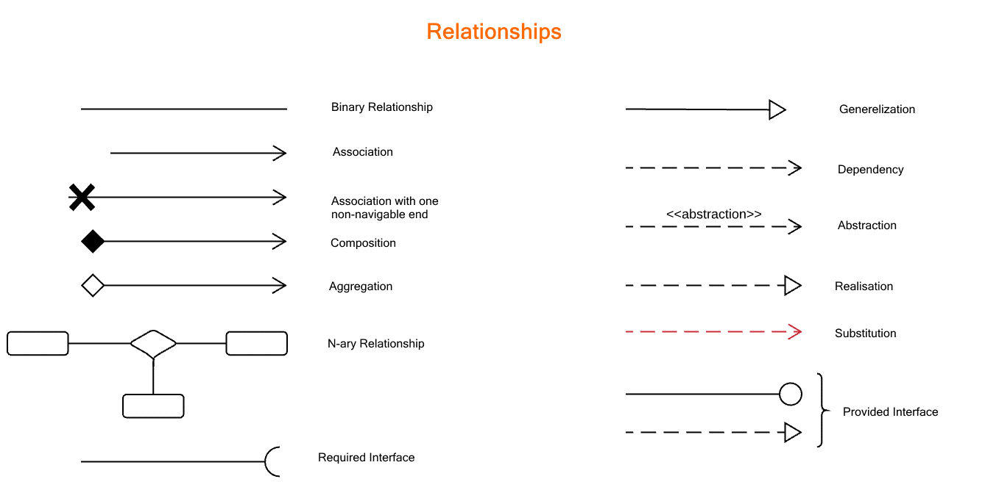

* Analyze an Object & Object Class Associations.
  + Choose Object Attributes (Data).
  + Choose Object Behaviors (Methods).
  + Interpret Encapsulation.
  + Create Multiplicity (a.k.a. Cardinality, Ordinality) - which is expressed in terms of 1 to 1, 1 to many or many to many.

* + Create Associations - They are represented by a solid line between classes. Associations are named using a verb or verb phrase which reflects the relationship. There is an association between these two classes shown by the solid line.
  + Create Bi-Directional Relationships - They are represented by a solid line between classes. Associations are named using a verb or verb phrase which reflects the relationship. There is an association between these two classes shown by the solid line.
  + Design a Generalization / Specialization Relationship – the relationship between a general and specific class.

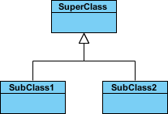

* + Each class instance of the specific class is also an indirect instance of the general class. So, specific classifiers inherit all aspects from the more general classifier.

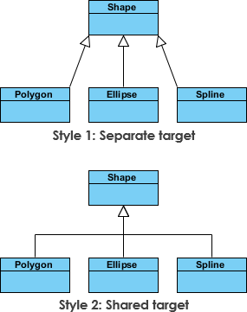

* Design the Relationships if said type is needed.
  + Aggregation - represents a "part of" relationship. The relationship is displayed as a solid line with a unfilled diamond at the association end, which is connected to the class that represents the aggregate.
  + Composition - where parts are destroyed when the whole is destroyed.
  + Dependency - might use an object of another class. If the object is not stored in any field (dynamic/derived), then this is modeled as a dependency relationship.
  + Realization -
* Model a Class Diagram (CD).

**REQUIREMENTS:**

1. You **MUST** draw your diagram using Visual Paradigm or Microsoft Visio Professional or Upgraded. The templates that your Class Diagram and UML are to be used.
2. For document type, use **UML Class diagram.**
3. Describe all relationships bi-directionally and specify multiplicity at each end of the relationship. For gen-spec relationships, specify {overlapping/disjoint and complete/incomplete}.
4. Add ALL attributes that are mentioned in previous assignments. Add methods that are mentioned or can be inferred. Use CRUDE, possibly expanding Update and Executable.
5. Use a TEXT BOX to document ALL your assumptions.
6. Potential Customer and Customer should be **SEPARATE**.
7. Checking Account and Savings Account should be **SEPARATE**.
8. Employee & Manager should be **SEPARATE**.
9. Copy and paste your diagram into the Word document (Assignment #7 - Student Answers.doc) where indicated, replacing the yellow, highlighted text. Add your name and submission date. NO .PNG files.
10. DO NOT zip your file
11. Attach the .VPP or .VSDX file(s) in case I have questions.
12. DO NOT use an old student’s file, as there are some changed system, actor, process names, etc. in this semester’s assignments.
13. Attach and submit the two files **separately** in Brightspace.